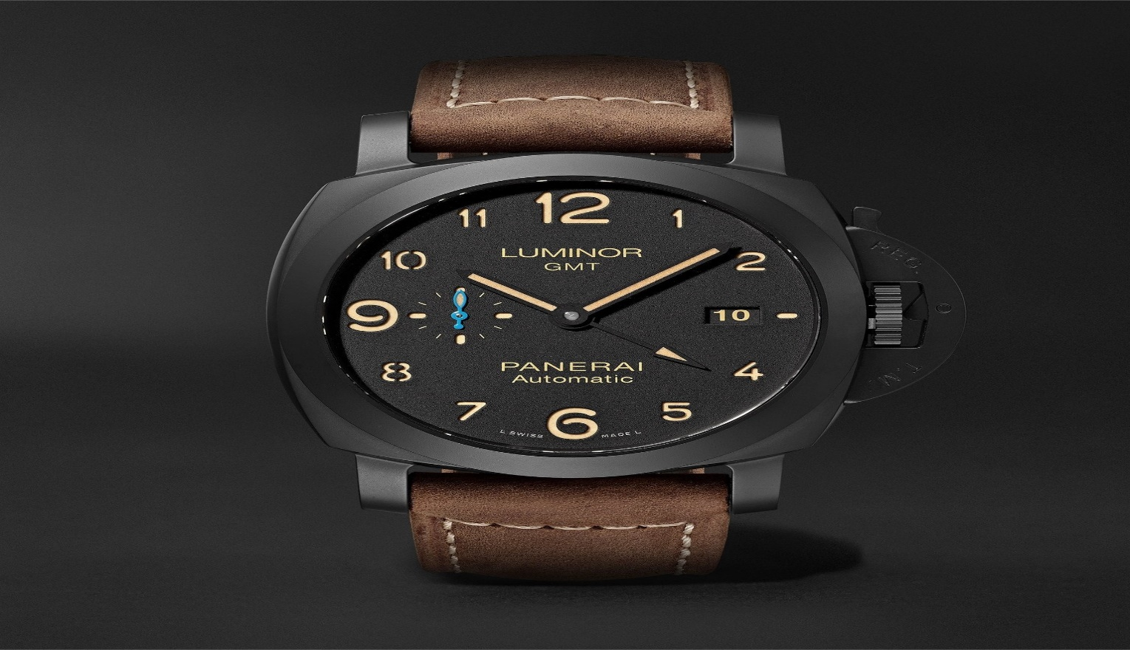PANERAI

DESCRIPTION: Panerai is an Italian-Swiss luxury watch brand known for its bold designs, robust craftsmanship, and deep-rooted connection to maritime history. Founded in 1860 in Florence, Italy, Panerai initially supplied precision instruments and timepieces to the Royal Italian Navy. Today, the brand combines Italian design aesthetics with Swiss watchmaking expertise, creating distinctive and highly durable watches.

Panerai’s most iconic collections include the **Luminor**, recognized for its signature crown-protecting bridge and luminous dial, and the **Radiomir**, featuring a cushion-shaped case and vintage military heritage. These watches are celebrated for their oversized cases, minimalist dials, and exceptional water resistance, making them a favorite among divers and adventurers